**Articles “a, an, the”**

**Types of Articles:**

In English, there are two main types of articles:

| **Article Type** | **Examples** | **Usage** |
| --- | --- | --- |
| **Indefinite Articles** | A, An | Used for non-specific or general nouns |
| **Definite Article** | The | Used for specific or previously mentioned nouns |

**1. The Definite Article “The”:**

**What is “the”?** “The” is known as the definite article in English. It is a tiny but mighty word that is used to specify a particular item or group of items, something that is already known or has been mentioned before.

**Article “The” – Examples:**

1. **The** cat is on **the** roof. (Specific cat on a specific roof)
2. I found **the** book you were looking for. (Specific book previously mentioned or known)

**When to use “the”?**

* **Specificity**: Use “the” before singular or plural nouns when you are talking about a specific thing or things.
  + e.g., “I saw **the** car parked outside.” (The car is specific.)
* **Superlative**: Use “the” before superlative adjectives to indicate the highest degree.
  + e.g., “She is **the** best singer in the world.” (The best singer of all, a unique position)
* **Unique or Defined Objects**: Use “the” before unique objects or objects in a particular group.
  + e.g., “The sun is a star.” (There’s only one sun we’re referring to.)

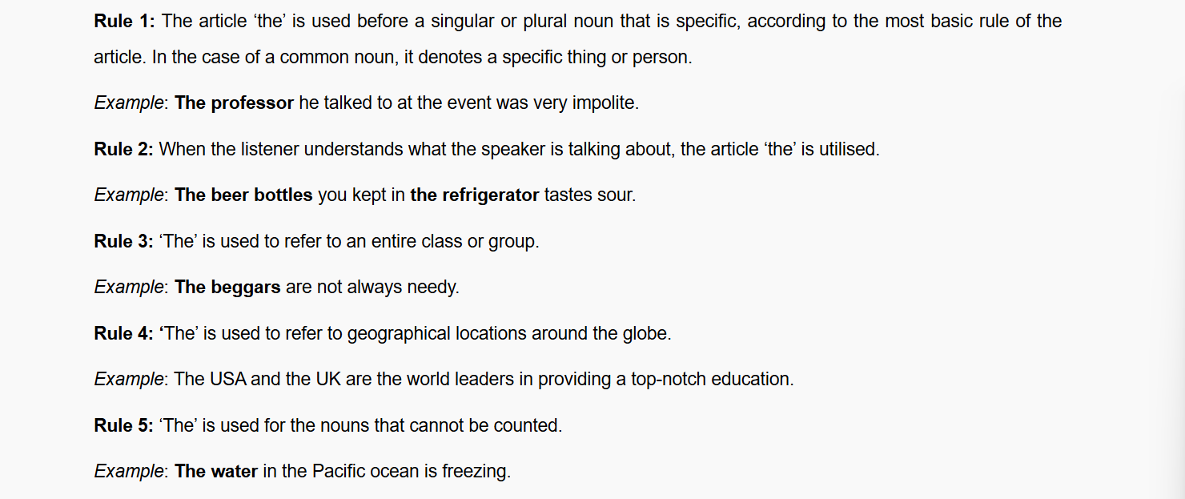

**2. The Indefinite Articles “A” and “An”:**

**What are “a” and “an”?** “A” and “an” are the two forms of indefinite articles in English. They are used when you are talking about something non-specific or for the first time.

**Articles “A” and “An” – Examples:**

1. I saw **a** cat in **a** tree. (Any cat in any tree, not specific)
2. She wants to buy **an** expensive car. (Any expensive car, not a specific one)

**When to use “a” and “an”?**

* **Consonant and Vowel Sounds**: Use “a” before words that start with a consonant sound, and “an” before words that start with a vowel sound.
  + e.g., “I saw **a** dog.” (dog starts with a consonant sound)
  + “She ate **an** apple.” (apple starts with a vowel sound)

**What Are Conjunctions?**

Conjunctions are the words we use to connect ideas in a sentence. They link words, [phrases](https://www.grammareer.com/types-of-phrases-in-english/#What_Are_Phrases), and [clauses](https://www.grammareer.com/types-of-clauses-in-english/#What_Is_a_Clause)so our language sounds smooth and natural. If we didn’t have conjunctions, our sentences would sound broken and incomplete.  
Examples:

* I like apples **and** oranges.
  + (*and* connects two words.)
* She is smart **but** sometimes careless.
  + (*but* connects two phrases.)
* I stayed home **because** it was raining.
  + (*because* connects two complete ideas and shows the reason.

**Types of Conjunctions**

**Conjunctions are of three main types. Each type has its own job in joining ideas.**

**1.Coordinating Conjunctions**

**2.Subordinating Conjunctions**

**3.Correlative Conjunctions**

**1.Coordinating Conjunctions**

These are the most common. They connect words, phrases, or even full sentences that are of the *same level* or importance. A simple way to remember them is with **FANBOYS**: *for, and, nor, but, or, yet, so.*

|  |  |
| --- | --- |
| **Conjunction** | **Example Sentence** |
| **For** | We stayed inside, **for** it was raining heavily. |
| **And** | Tom plays football **and** cricket. |
| **Nor** | She doesn’t like tea, **nor** does she enjoy coffee. |
| **But** | The task was simple, **but** important. |
| **Or** | Do you prefer pizza **or** pasta? |
| **Yet** | He was tired, **yet** he kept working. |
| **So** | It was late, **so** we went home. |

Always keep in mind that when two complete sentences are joined with a coordinating conjunction, always put a comma before it. Like:

* She loves drawing, **and** her brother enjoys painting.
* Correlative Conjunctions
* These always come in pairs. Think of them as partners that work together. Common ones are: ***either…or, neither…nor, both…and, not only…but also****.*  
  Examples:

|  |  |
| --- | --- |
| **Conjunction Pair** | **Example Sentence** |
| **Either / or** | We will **either** watch a movie **or** play cricket. |
| **Neither / nor** | **Neither** the dog **nor** the cat is allowed inside. |
| **Not only / but also** | He **not only** sings well **but also** writes songs. |
| **Both / and** | **Both** honesty **and** hard work bring success. |
| **Whether / or** | She was unsure **whether** to laugh **or** cry. |
| **As / so** | **As** the sun sets, **so** the evening begins. |
| **Rather / than** | I’d **rather** walk **than** take the bus. |

* The important thing here is balance—if you start with one, you must use its partner correctly.

**2.**[**Subordinating Conjunctions**](https://www.grammareer.com/subordinating-conjunctions/)

These are used when one part of the sentence depends on the other. They connect a main idea with a supporting idea. Common ones are: **because, although, since, if, until, when, while**.

* I stayed home **because** it was raining.
* She smiled **although** she was tired.
* We will wait here **until** the bus comes.
* **If** you study hard, you will pass the exam.

The part with the subordinating conjunction (the dependent clause) cannot stand alone.  
❌ Because it was raining.  
✔️ I stayed home **because it was raining.**

If the dependent clause comes first, use a comma:

* **Because it was raining,** I stayed home.

**Conjunction Rules**

When using conjunctions, it’s important to follow style rules, especially knowing where to place them in a sentence and when commas are needed.

**Starting Sentences with Conjunctions**

Some people believe it’s wrong to begin a sentence with words like *and* or *but*. That’s something many of us were told in school, but it isn’t true. You can start a sentence with a conjunction if it helps your meaning come across more clearly.  
For example:

* I was waiting for the bus. **But** it never came.
* She finished her homework. **And** she went out to play.

See how natural that sounds? Starting with a conjunction can give your sentence a little extra emphasis.

Just remember—don’t do it too often. If you begin too many sentences this way, your writing can sound repetitive. Use it when you really want to highlight something.

**Use a comma before a conjunction in a**[**compound sentence**](https://www.grammareer.com/compound-sentence/)

When you join **two complete sentences** (independent clauses) with a conjunction like *and, but, or, so,* or *yet*, you must place a comma before the conjunction.

* **Example:**  
  I was tired, **but** I kept working.
  + (Both parts — *I was tired* and *I kept working* — can stand alone as full sentences, so the comma is needed.)

Comma as a small pause that makes your sentence easier to read and prevents confusion.

**No Comma Needed for Words/Phrases**

If a conjunction is only linking two words or short phrases, you don’t need a comma. Adding one would break the natural flow of the sentence.

* **Example:**  
  We need pens **and** pencils.
  + (The conjunction *and* is just connecting two words, so no comma is necessary.

The rule is simple: **no comma unless you’re connecting two full sentences.**

List of Most Commonly Used Conjunctions

Here are some of the most useful conjunctions to include in your everyday speaking and writing.

|  |  |  |
| --- | --- | --- |
| But | If | Untill |
| And | Wheres | In case |
| Or | As soon as | Rather than |
| Although | Even if | Or else |
| Because | Still | Both…and |
| Yet | Neither…nor | Whether…or |
| Not only… but also | For | As if |
| Though | In addition to | While |
| After | Before | So that |
| So | When | Either.. or |